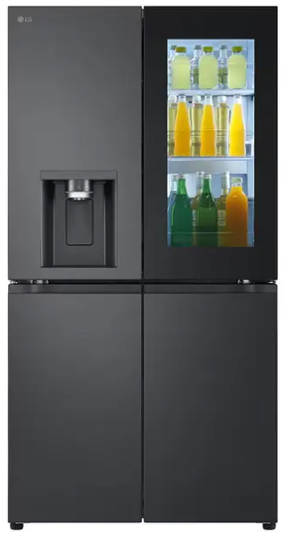

LG InstaView Refrigerator
Rs.835,822
LG InstaView Door-in-Door refrigerator GR-X39FFCRB brings premium black glass styling, cleaner dispensing, and smart ThinQ connectivity.

Specifications
- Model: GR-X39FFCRB
- Type: InstaView Refrigerator
- Finish: Essence Black Steel
- Smart Control: LG ThinQ

Key Features
- InstaView Door-in-Door
- UVnano dispenser
- LINEARCooling
- Hygiene Fresh+

